**Report**

|  |  |
| --- | --- |
| **Name** | **Sania Bibi** |
| **Roll No** | **BSCS-2019-67** |

***Project:***

***Bluetooth Controlled Robot Car***

**Submitted to: DR TAHIR MEHMOOD**

* **Introduction**

In this project, we will make Bluetooth Controlled Robot Car using Arduino UNO. In this project we will control our car using Bluetooth which is connected to our cell phone and car. We move our car forward, backward, left and right by controlling buttons on cell phone. We will download app on our phone and there will be 1234 buttons which are used for controlling.

The main purpose of this project is to develop a remote user interface to control a Robot via a wireless technology. There is a need to communicate with the robot remotely in order to control the robot movements and pass critical data both ways.

* **Hardware components required**
* DC motors
* Ardunio UNO
* Wheels
* Battery(9v)
* Hc-05 Bluetooth module
* Wires
* L298 motor drive
* Mobile with Bluetooth
* **Software components required**
* **Code:**

char t;

void setup() {

pinMode(9,OUTPUT); //left motors forward

pinMode(10,OUTPUT); //left motors reverse

pinMode(11,OUTPUT); //right motors forward

pinMode(12,OUTPUT); //right motors reverse

Serial.begin(9600);

}

void loop() {

if(Serial.available()){

t = Serial.read();

Serial.println(t);

}

if(t == '1'){ //move forward(all motors rotate in forward direction)

digitalWrite(9,HIGH);

digitalWrite(10,LOW);

digitalWrite(11,HIGH);

digitalWrite(12,LOW);

}

else if(t == '2'){ //move reverse (all motors rotate in reverse direction)

digitalWrite(9,LOW);

digitalWrite(10,HIGH);

digitalWrite(11,LOW);

digitalWrite(12,HIGH);

}

else if(t == '3'){ //turn right (left side motors rotate in forward direction, right side motors doesn't rotate)

digitalWrite(9,LOW);

digitalWrite(10,LOW);

digitalWrite(11,HIGH);

digitalWrite(12,LOW);

}

else if(t == '4'){ //turn left (right side motors rotate in forward direction, left side motors doesn't rotate)

digitalWrite(9,HIGH);

digitalWrite(10,LOW);

digitalWrite(11,LOW);

digitalWrite(12,LOW);

}

else if(t == '5'){ //STOP (all motors stop)

digitalWrite(9,LOW);

digitalWrite(10,LOW);

digitalWrite(11,LOW);

digitalWrite(12,LOW);

}

delay(100);

}

* **Implementation**

A smart phone Android operated car. Now here is a simple to control your robot/robo car using Bluetooth module HC-06 with your android Smartphone device. The controlling devices of the whole system are an Arduino, Bluetooth module, DC motors are interfaced. The data receive by the Bluetooth module from android smart phone is fed as input to the controller. The controller acts accordingly on the DC motor of the robot car. The robot car in the project can be made to move in all the four directions using the android phone. The direction of the robot is indicators using LED indicators of the car system. Initial step of this is to pair HC-05 Bluetooth module with mobile. Once the connection is established we need to press connect so that it gets triggered with a default password. There will be a predefined lookup table coded in a program which contents the information of direction and ASCII code.

* **Circuit diagrams**

**1:**

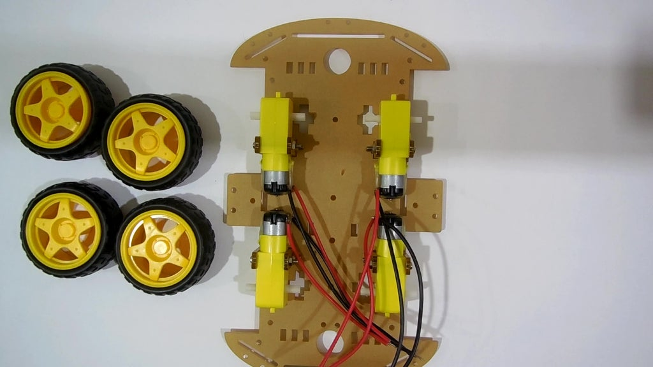

**2:**

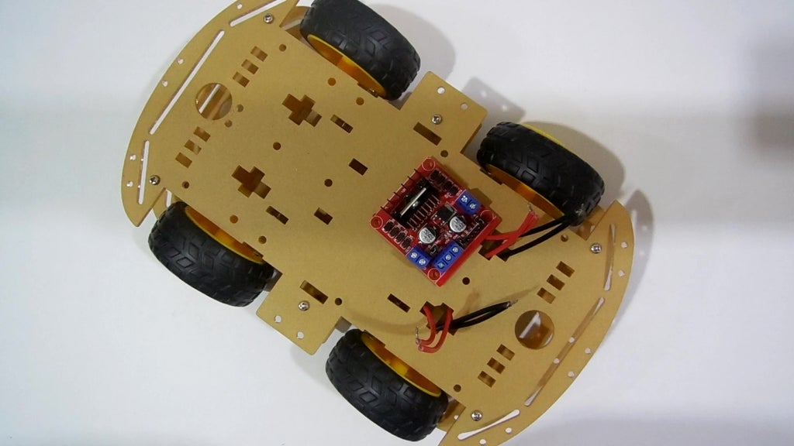

**3:**

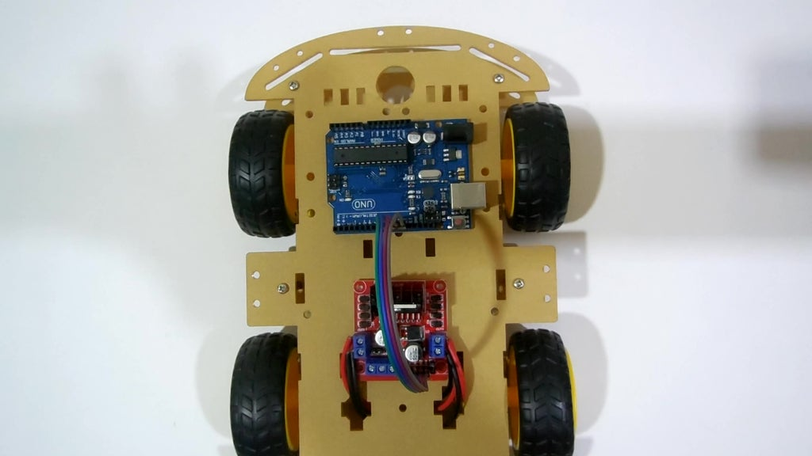

**4:**

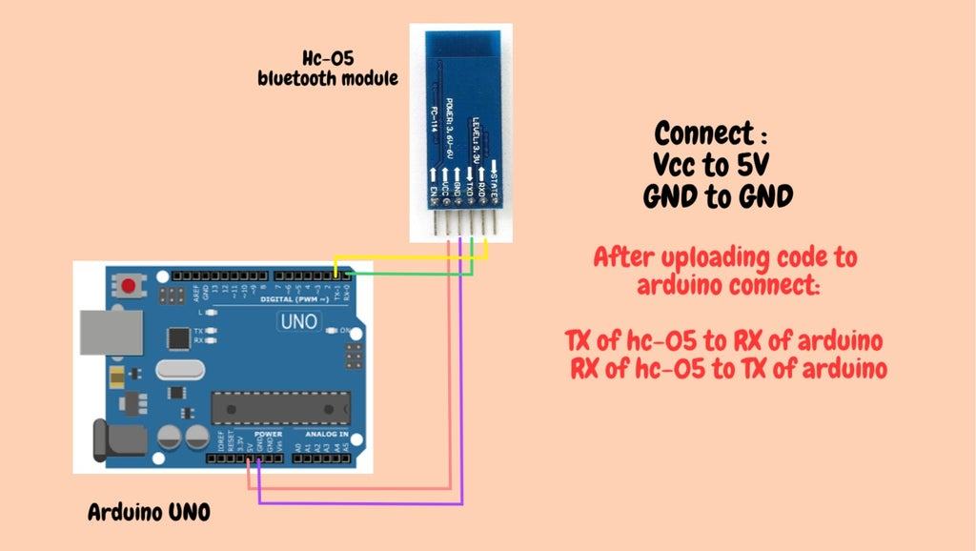

**5:**

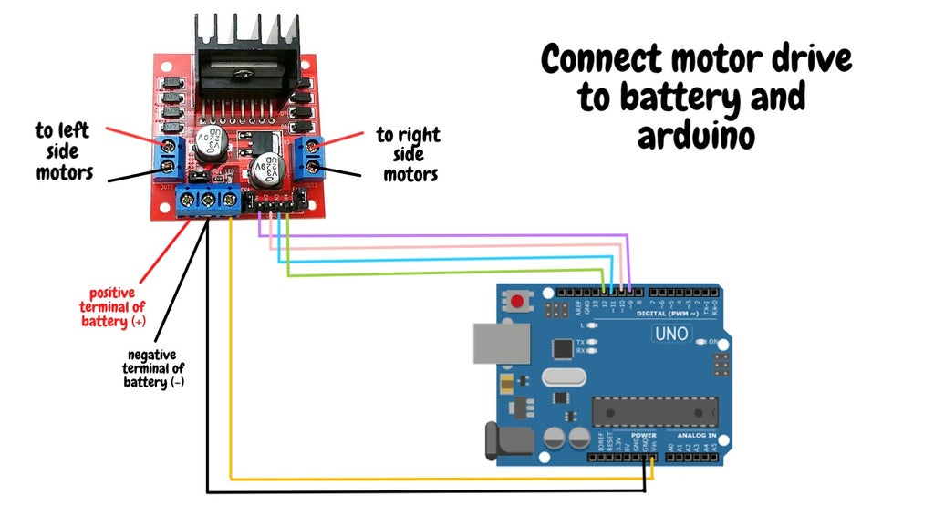

**6:**

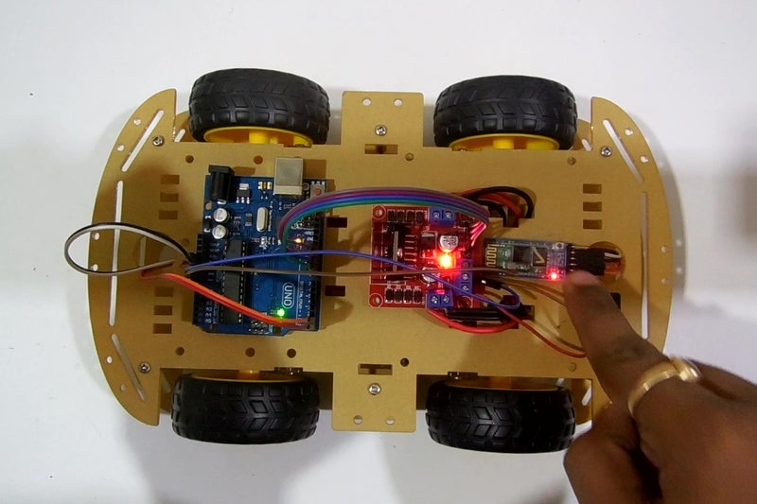

**7:**

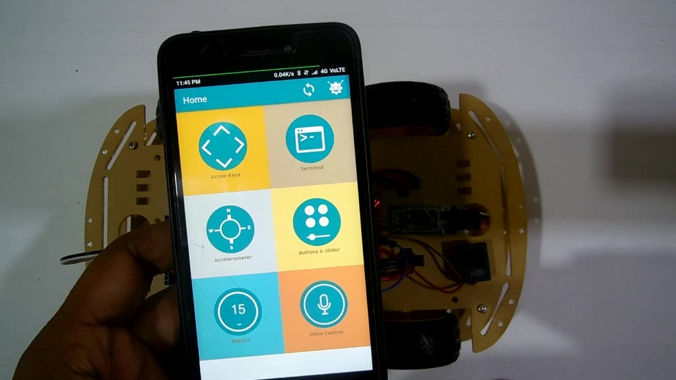

**8:**

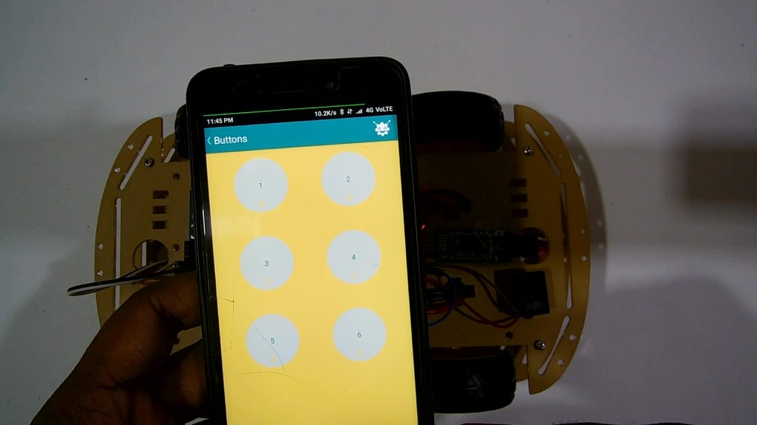

* **Advantages:**
* Simple to operate.
* Small parking area required.
* Reduce human effort.
* Control car from outside.
* Reduce parking difficulties.
* Easy to control car in off-road.

In future, we will also add more sensors so that car will be automatically controlled auto parking and auto turning. It will also increase the security for the both car and passengers in terrain condition.

* **Conclusion**

We achieved Bluetooth control communication between the mobile -via android application- and the vehicle. The knowledge is ever expanding and so are the problems which the mankind strive to solve. In this spirit, it is hoped that the current activity will lead to further enhancements.

* **References**
* [**https://www.instructables.com/Arduino-Bluetooth-Controlled-Robot-Car-1/**](https://www.instructables.com/Arduino-Bluetooth-Controlled-Robot-Car-1/)
* [**https://pastebin.com/bfKg6tYN**](https://pastebin.com/bfKg6tYN)

***The End***